1. **Kafka Integration with C#**

**Outline:**

* Introduction to Kafka
* Kafka Architecture
* Topics
* Partitions
* Brokers
* Kafka plug in .NET
* Installation of Kafka
* Basics of Zookeeper
* Demo

**Hands On:**

1. Create a Chat Application which uses Kafka as a streaming platform and consume the chat messages in the command prompt.
2. Create a Chat Application using C# Windows Application using Kafka and consume the message in different client applications.

**Implementation:**

Kafka server running:

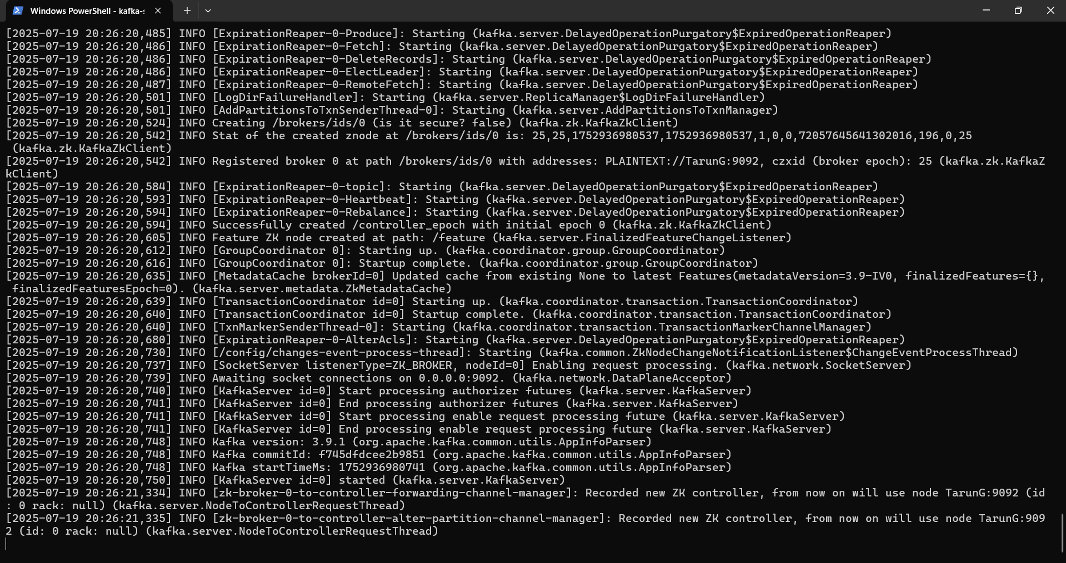

Zookeeper running:

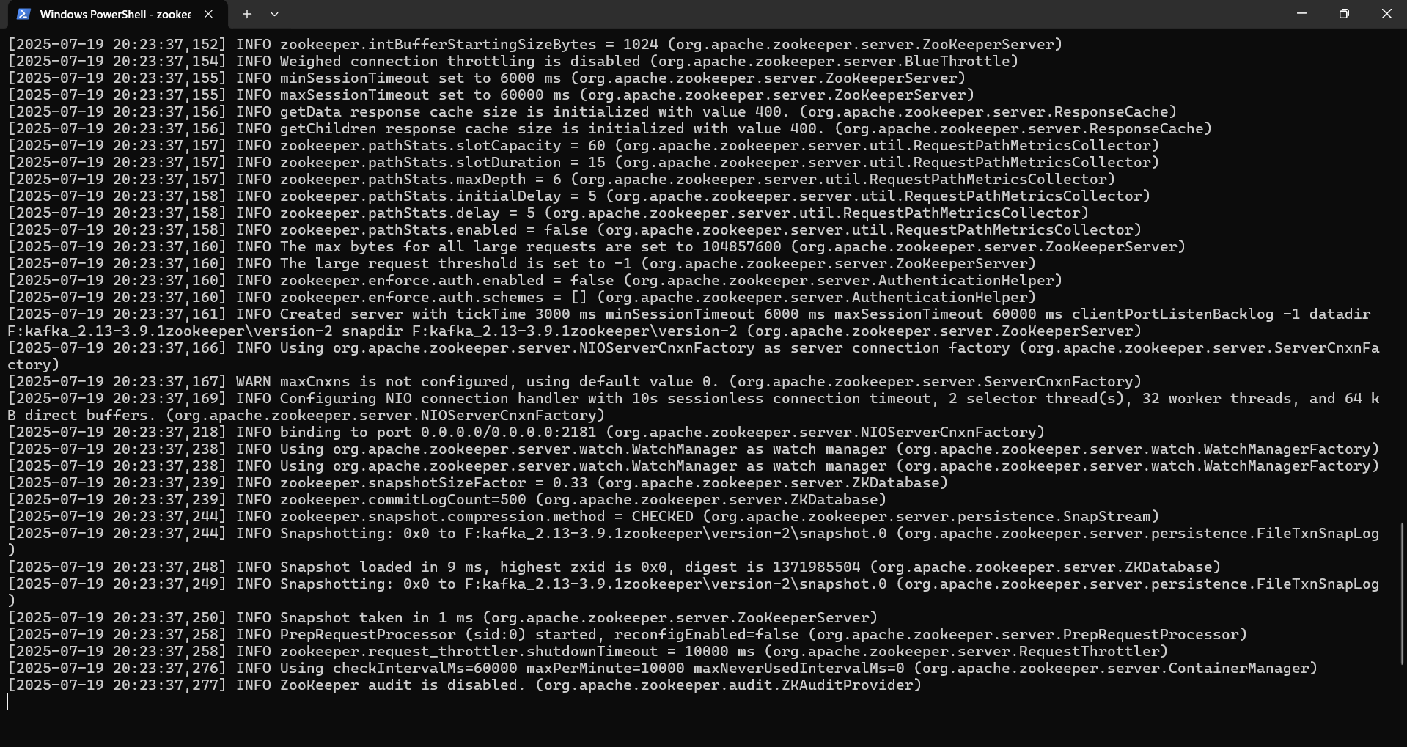

Topic created:

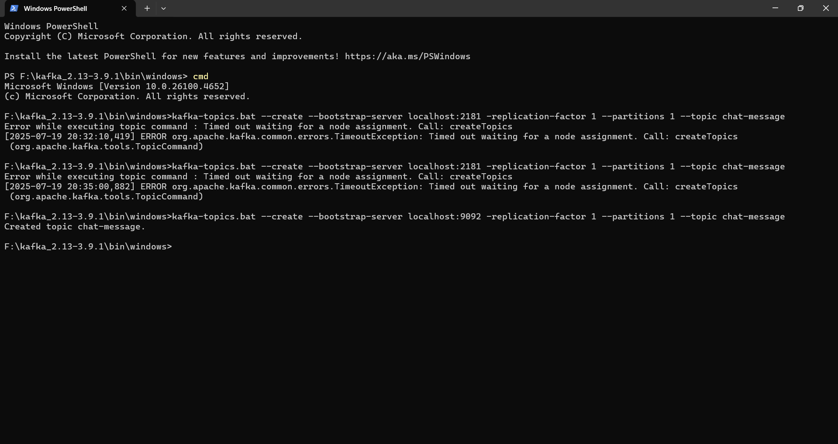

Creating publisher in command prompt:

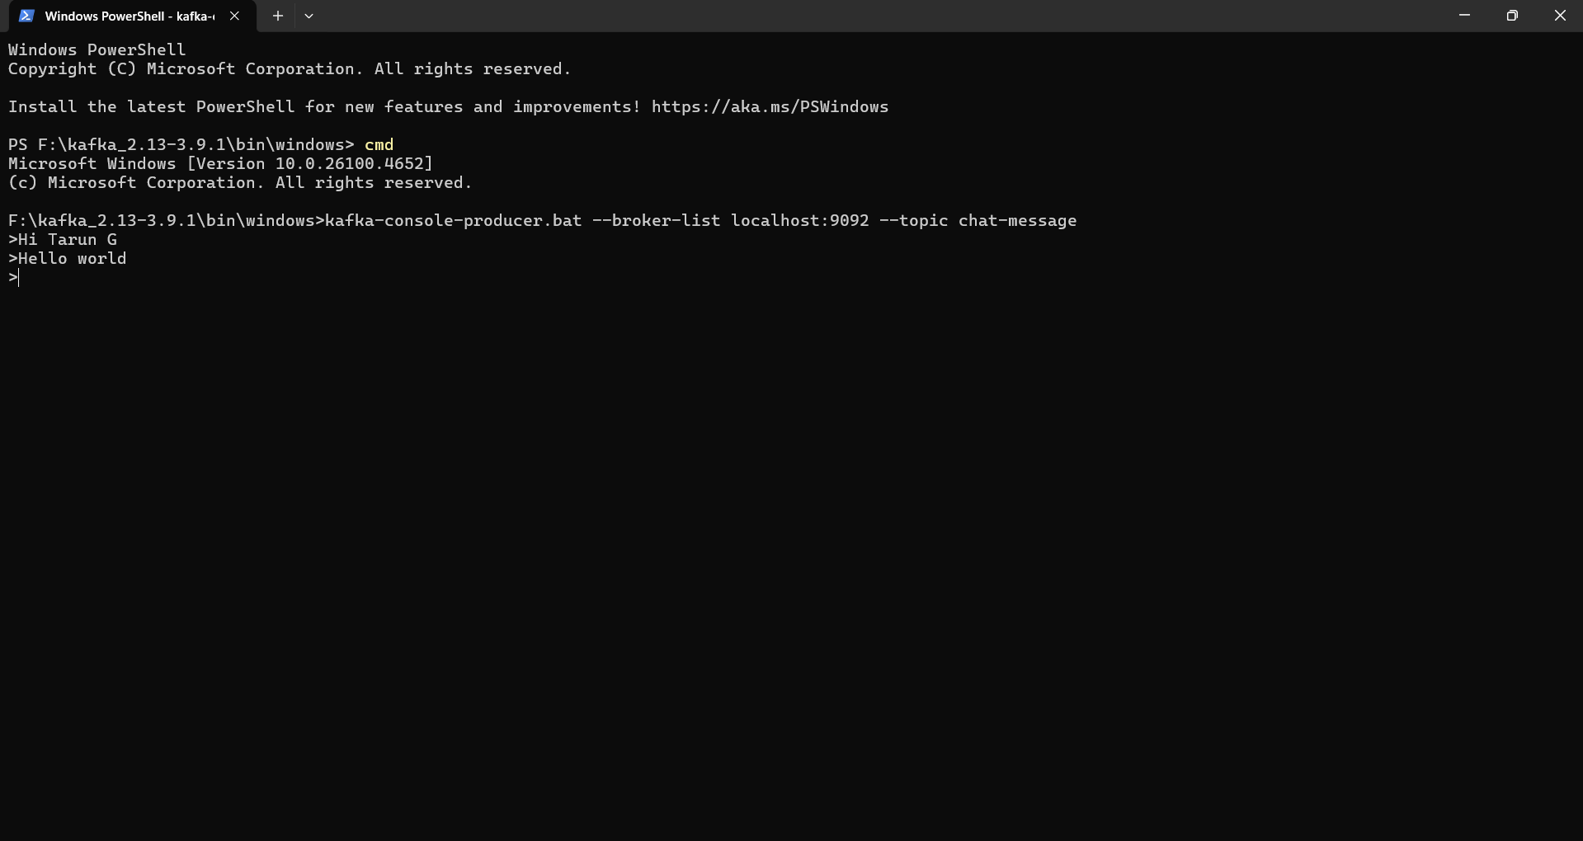

Client application:

